ENTERPRISE NETWORK
TECHNICAL DOCUMENTATION

Three-Tier Hierarchical LAN Design
Cisco Packet Tracer Lab — Portfolio Project

Devices: WAN Router · R1 · R2 · L3SW1 · L3SW2 · SW1 · SW2
Protocols: OSPF · HSRP · PVST+ · LACP · PAT · DHCP · DNS · SSH · DAI · DHCP Snooping · ACL

Introduction
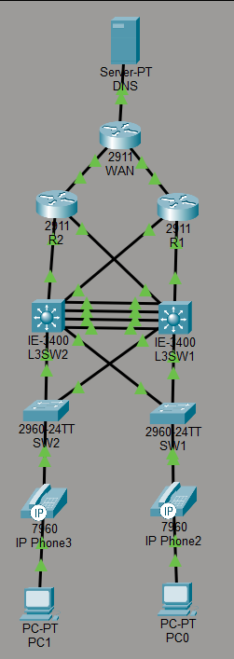
This document presents the technical design and configuration of an enterprise-grade network built in Cisco Packet Tracer as a hands-on portfolio project. The topology implements a three-tier hierarchical LAN model — the industry-standard architecture used in campus and enterprise environments — consisting of Access, Distribution, and Core layers.
The network was designed from the ground up with redundancy, security, and scalability in mind. Every layer incorporates failover mechanisms: HSRP provides transparent gateway redundancy at the distribution layer, LACP EtherChannel aggregates inter-switch links, Rapid PVST+ controls Layer 2 topology with root placement aligned to HSRP active roles, and dual border routers provide independent WAN exit paths per VLAN. OSPF handles dynamic routing convergence across all Layer 3 devices.
Security is enforced at every tier. Access layer switches implement port security, DHCP snooping, and Dynamic ARP Inspection to protect against common LAN attacks. Distribution layer switches enforce inter-VLAN access control via extended ACLs. All devices are hardened with SSH-only remote access, local authentication, and encrypted credentials.
The document covers IP addressing, VLAN design, spanning tree configuration, HSRP and OSPF deployment, NAT/PAT, DHCP with relay, and per-device configuration summaries, followed by a full set of verification commands.
Username and password for every device:
USERNAME: admin PASSWORD: cisco123

1. Topology Overview

1.1 Design Model
This network implements a three-tier hierarchical LAN architecture consisting of Access, Distribution, and Core layers. The design provides redundancy, deterministic traffic paths, and clear separation of responsibilities between tiers.

Tier | Devices | Role
Core / WAN Edge | R1, R2 | Border routing, NAT/PAT, OSPF default route origination, DHCP server
Distribution | L3SW1, L3SW2 | Inter-VLAN routing, HSRP gateway redundancy, LACP EtherChannel, STP root, ACL enforcement
Access | SW1, SW2 | End-device connectivity, port security, DHCP snooping, DAI, PortFast/BPDUGuard

1.2 Redundancy Strategy
Redundancy is implemented at every layer:
- Dual uplinks from each access switch to both L3 switches (active/standby paths via STP)
- LACP EtherChannel (4-link port-channel) between L3SW1 and L3SW2 for inter-distribution bandwidth and resilience
- HSRP on both L3 switches for each VLAN — one switch is active gateway, the other standby
- Dual routers (R1, R2) providing independent WAN exit paths per VLAN
- OSPF running across all L3 devices for dynamic route convergence

1.3 Traffic Flow Summary
VLAN 10 (PC0 side): PC0 → SW1 → L3SW1/L3SW2 → R1 → WAN
VLAN 20 (PC1 side): PC1 → SW2 → L3SW1/L3SW2 → R2 → WAN
Both VLANs use their respective HSRP virtual IP as the default gateway (192.168.10.254 and 192.168.20.254). Inter-VLAN traffic is routed at the distribution layer via the L3 switch SVIs.

2. IP Addressing

2.1 WAN / Transit Subnets
Subnet | Purpose | Device A | IP A | Device B | IP B
203.0.16.0/30 | WAN ↔ R1 | WAN (Gi0/1) | 203.0.16.2 | R1 (Gi0/0) | 203.0.16.1
203.0.16.4/30 | WAN ↔ R2 | WAN (Gi0/2) | 203.0.16.6 | R2 (Gi0/0) | 203.0.16.5
198.0.0.0/30 | R1 ↔ L3SW1 | R1 (Gi0/1) | 198.0.0.2 | L3SW1 (Gi1/9) | 198.0.0.1
198.0.0.4/30 | R1 ↔ L3SW2 | R1 (Gi0/2) | 198.0.0.6 | L3SW2 (Gi1/10) | 198.0.0.5
198.0.0.8/30 | R2 ↔ L3SW2 | R2 (Gi0/1) | 198.0.0.10 | L3SW2 (Gi1/9) | 198.0.0.9
198.0.0.12/30 | R2 ↔ L3SW1 | R2 (Gi0/2) | 198.0.0.14 | L3SW1 (Gi1/10) | 198.0.0.13

2.2 Client Subnets (VLAN SVIs)
VLAN | Subnet | L3SW1 SVI | L3SW2 SVI | HSRP VIP | HSRP Active
VLAN 10 | 192.168.10.0/24 | 192.168.10.253 | 192.168.10.252 | 192.168.10.254 | L3SW1
VLAN 20 | 192.168.20.0/24 | 192.168.20.252 | 192.168.20.253 | 192.168.20.254 | L3SW2
VLAN 50 (Voice) | N/A (tagged only) | — | — | — | —
VLAN 99 (Native) | N/A (management) | — | — | — | —

2.3 Loopback Addresses
Device | Loopback0 IP | OSPF Router-ID
R1 | 1.1.1.1/32 | 1.1.1.1
R2 | 2.2.2.2/32 | 2.2.2.2
L3SW1 | 3.3.3.3/32 | 3.3.3.3
L3SW2 | 4.4.4.4/32 | 4.4.4.4
WAN | 1.2.3.4/32 | N/A

2.4 DHCP Pools
Pool | Server | Network | Default Router | DNS | Excluded
VLAN10 | R1 | 192.168.10.0/24 | 192.168.10.254 | 8.8.8.8 | 192.168.10.252–254
VLAN20 | R2 | 192.168.20.0/24 | 192.168.20.254 | 8.8.8.8 | 192.168.20.252–254

3. VLAN Design
VLAN ID | Name / Purpose | Tagged On | Access Ports
10 | Data — PC side (SW1) | Gi trunks throughout | SW1 Fa0/1
20 | Data — PC side (SW2) | Gi trunks throughout | SW2 Fa0/1
50 | Voice — IP Phones | Gi trunks throughout | SW1/SW2 Fa0/1 (voice VLAN)
99 | Native VLAN (management) | All trunk links | None

3.1 Trunk Configuration
All inter-switch and switch-to-router uplinks are configured as 802.1Q trunks with:
- Native VLAN set to 99 on all trunk ports
- Allowed VLANs explicitly pruned per link (no 'allowed all')
- DTP disabled (switchport nonegotiate) on all trunk ports
- Speed manually set to 1000 Mbps on all uplinks

4. Spanning Tree (PVST+)

4.1 Root Bridge Assignments
Root bridge placement is aligned with HSRP active roles to ensure traffic follows the same path at both Layer 2 and Layer 3, preventing suboptimal forwarding.

VLAN | STP Root (Primary) | STP Priority | HSRP Active
10, 50 | L3SW1 | 24576 | L3SW1
20, 99 | L3SW2 | 24576 | L3SW2

4.2 Access Layer STP Settings
All access ports on SW1 and SW2 are configured with:
- PortFast — eliminates 30-second listening/learning delay for end devices
- BPDUGuard — shuts down port immediately if a BPDU is received (prevents rogue switch connection)
- STP priority set to 61440 on access switches to ensure they are never elected root

4.3 EtherChannel (LACP)
A 4-link LACP EtherChannel (Port-channel 1) connects L3SW1 and L3SW2 on Gi1/5–Gi1/8. L3SW1 runs LACP active mode; L3SW2 runs LACP passive mode. STP treats the port-channel as a single logical link, eliminating the need to block individual physical links between the distribution switches.

5. HSRP — Gateway Redundancy
Group | VLAN | Virtual IP | Active | Priority (Active) | Standby | Priority (Standby) | Preempt
1 | 10 | 192.168.10.254 | L3SW1 | 100 (default) | L3SW2 | 90 | L3SW1
2 | 20 | 192.168.20.254 | L3SW2 | 100 (default) | L3SW1 | 90 | L3SW2

Preempt is enabled on the active switch for each group, ensuring it reclaims the active role after recovering from a failure. Clients use the virtual IP as their default gateway — they are unaware of which physical switch is currently active.

6. OSPF

6.1 Design
Single-area OSPF (Area 0) runs across all Layer 3 devices. R1 and R2 inject a default route into OSPF using default-information originate, allowing all downstream devices to reach the internet without static routes.
Device | Router-ID | Networks Advertised | Notes
R1 | 1.1.1.1 | 198.0.0.0/27 | Injects default route
R2 | 2.2.2.2 | 198.0.0.0/27 | Injects default route
L3SW1 | 3.3.3.3 | 198.0.0.0/27, 192.168.10.0/24, 192.168.20.0/24 | Passive on access-facing ports
L3SW2 | 4.4.4.4 | 198.0.0.0/27, 192.168.10.0/24, 192.168.20.0/24 | Passive on access-facing ports

6.2 Passive Interfaces
Access-facing interfaces on L3SW1 and L3SW2 are configured as OSPF passive interfaces. This prevents OSPF hello packets from being sent toward access switches (which do not run OSPF) while still advertising those connected networks into OSPF.
6.3 Static Routes
Static host routes are configured on Layer 3 devices to ensure reachability to loopback interfaces used as OSPF Router IDs and management addresses.
Example:
- R1 → 1.1.1.1/32 ip route 1.1.1.1 255.255.255.255 GigabitEthernet1/9 (FROM L3SW1)
- R2 → 2.2.2.2/32 ip route 2.2.2.2 255.255.255.255 GigabitEthernet1/10 (FROM L3SW1)
- L3SW2 → 4.4.4.4/32 ip route 4.4.4.4 255.255.255.255 192.168.20.253 (FROM L3SW1)
These routes provide deterministic reachability for management and testing purposes.

7. NAT / PAT

7.1 Design
PAT (Port Address Translation, also called NAT overload) is configured on both R1 and R2. Each router translates inside traffic to its own WAN interface IP, allowing all internal hosts to share a single public IP per router.

Router | Inside Interfaces | Outside Interface | Public IP | ACL Matches
R1 | Gi0/1 (198.0.0.2), Gi0/2 (198.0.0.6) | Gi0/0 | 203.0.16.1 | 192.168.10.0/24, 192.168.20.0/24
R2 | Gi0/1 (198.0.0.10), Gi0/2 (198.0.0.14) | Gi0/0 | 203.0.16.5 | 192.168.10.0/24, 192.168.20.0/24

7.2 NAT Symmetry
Each VLAN is routed to a single router based on the HSRP active/STP root path. This ensures NAT symmetry — return traffic always enters through the same router that translated the outbound flow. Asymmetric NAT (where outbound and inbound traverse different routers) would cause session drops and is avoided by the aligned HSRP/STP design.

7.3 DHCP Relay
Because DHCP servers (R1, R2) are multiple L3 hops away from clients, ip helper-address is configured on each VLAN SVI on both L3 switches. This forwards DHCP broadcast Discover packets as unicast to the appropriate DHCP server.

L3 Switch | SVI | Helper Address | Points To
L3SW1 | Vlan10 | 198.0.0.2 | R1 Gi0/1
L3SW1 | Vlan20 | 198.0.0.14 | R2 Gi0/2
L3SW2 | Vlan10 | 198.0.0.6 | R1 Gi0/2
L3SW2 | Vlan20 | 198.0.0.10 | R2 Gi0/1

8. Security

8.1 SSH
Telnet is disabled on all devices. SSH is the only permitted remote access method, enforced via transport input ssh on all VTY lines. A local user (admin, privilege 15) is configured on every device. RSA keys are generated with 2048-bit modulus. Password encryption is enabled globally on all devices (service password-encryption).

8.2 Port Security (SW1, SW2)
Setting | Value | Purpose
Maximum MACs | 2 | Allows one PC + one IP phone per port
Mode | Sticky | Dynamically learns and saves authorized MACs
Violation action | Restrict | Drops unauthorized frames, logs violation, port stays up
Aging time | 5 minutes | Clears sticky MACs after inactivity

8.3 DHCP Snooping (SW1, SW2)
DHCP snooping is enabled per VLAN (VLAN 10 on SW1, VLAN 20 on SW2). Upstream trunk ports (Gi0/1, Gi0/2) are marked as trusted, allowing DHCP replies from the infrastructure. Access ports remain untrusted, blocking rogue DHCP servers.

Note: ip dhcp snooping information option is disabled on both switches. This removes Option 82 insertion, which is required when using Cisco router-based DHCP servers with ip helper-address — Option 82 on untrusted ports would otherwise silently drop all DHCP replies.

8.4 Dynamic ARP Inspection (SW1, SW2)
DAI is enabled per VLAN (VLAN 10 on SW1, VLAN 20 on SW2). It validates ARP packets against the DHCP snooping binding table, dropping ARP replies that do not match a known IP-to-MAC binding. Upstream trunk ports are trusted for ARP inspection.

8.5 ACLs — Inter-VLAN SSH Restriction
Extended named ACLs are applied on both L3 switches to block SSH traffic between VLAN 10 and VLAN 20. VTY lines are protected using the access-class command. Management access is filtered before an SSH session is established.

ACL Name | Applied On | Direction | Rule
BLOCK_SSH_VLAN10 | L3SW2 | in | Deny TCP 192.168.10.0/24 any eq 22; permit ip any any
BLOCK_SSH_VLAN20 | L3SW1 | in | Deny TCP 192.168.20.0/24 any eq 22; permit ip any any

9. DNS
9.1 Design
A dedicated DNS server (Server-PT) is connected to the WAN router, sitting outside the internal network and representing an internet-facing DNS service. The server runs Packet Tracer's built-in DNS service with the following A records:
Number | Hostname | Type | Resolve To
0 | dns.google.com | A Record | 8.8.8.8
1 | l3sw1 | A Record | 3.3.3.3
2 | l3sw2 | A Record | 4.4.4.4
3 | r1 | A Record | 1.1.1.1
4 | r2 | A Record | 2.2.2.2
5 | testping | A Record | 1.2.3.4

9.2 Client DNS Configuration
All DHCP pools (R1 for VLAN10, R2 for VLAN20) distribute 8.8.8.8 as the DNS server address. Clients resolve hostnames by querying the DNS server directly. The testping record pointing to 1.2.3.4 (WAN loopback) serves as a convenient end-to-end connectivity test — a client pinging testping by name exercises DHCP, DNS, routing, NAT, and WAN reachability in a single test.
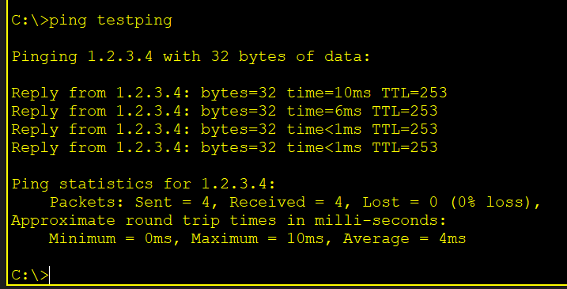

10. Per-Device Configuration Summary

R1 — Border Router (Core/WAN Edge)
- OSPF 1, router-id 1.1.1.1, default-information originate
- PAT: access-list 1 (192.168.10/24 + 192.168.20/24) → Gi0/0 overload
- DHCP pool VLAN10: 192.168.10.0/24, gateway 192.168.10.254, DNS 8.8.8.8
- DHCP excluded: 192.168.10.252–254
- Default route: 0.0.0.0/0 → Gi0/0 (WAN)
- Loopback0: 1.1.1.1/32
- SSH enabled, service password-encryption

R2 — Border Router (Core/WAN Edge)
- OSPF 1, router-id 2.2.2.2, default-information originate
- PAT: access-list 1 (192.168.10/24 + 192.168.20/24) → Gi0/0 overload
- DHCP pool VLAN20: 192.168.20.0/24, gateway 192.168.20.254, DNS 8.8.8.8
- DHCP excluded: 192.168.20.252–254
- Default route: 0.0.0.0/0 → Gi0/0 (WAN)
- Loopback0: 2.2.2.2/32
- SSH enabled, service password-encryption

L3SW1 — Distribution Switch
- OSPF 1, router-id 3.3.3.3, passive on Gi1/3 and Gi1/4
- HSRP Group 1 (VLAN10): active (preempt), VIP 192.168.10.254
- HSRP Group 2 (VLAN20): standby, priority 90
- STP root for VLAN 10, 50 (priority 24576); secondary for VLAN 20, 99 (priority 28672)
- LACP active on Gi1/5–Gi1/8 (Port-channel 1)
- BLOCK_SSH_VLAN20 inbound on VTY
- ip helper-address on Vlan10 (→ R1) and Vlan20 (→ R2)
- Loopback0: 3.3.3.3/32
- SSH enabled, service password-encryption

L3SW2 — Distribution Switch
- OSPF 1, router-id 4.4.4.4, passive on Gi1/3 and Gi1/4
- HSRP Group 2 (VLAN20): active (preempt), VIP 192.168.20.254
- HSRP Group 1 (VLAN10): standby, priority 90
- STP root for VLAN 20, 99 (priority 24576); secondary for VLAN 10, 50 (priority 28672)
- LACP passive on Gi1/5–Gi1/8 (Port-channel 1)
- BLOCK_SSH_VLAN10 inbound on VTY
- ip helper-address on Vlan10 (→ R1) and Vlan20 (→ R2)
- Loopback0: 4.4.4.4/32
- SSH enabled, service password-encryption

SW1 — Access Switch (VLAN 10 side)
- Access port Fa0/1: VLAN 10 data, VLAN 50 voice
- Port security: max 2 MACs, sticky, restrict violation, 5-min aging
- PortFast + BPDUGuard on Fa0/1
- DHCP snooping VLAN 10, Option 82 disabled, trunks trusted
- DAI VLAN 10, trunks trusted
- STP priority 61440 (never root)
- SSH enabled, service password-encryption

SW2 — Access Switch (VLAN 20 side)
- Access port Fa0/1: VLAN 20 data, VLAN 50 voice
- Port security: max 2 MACs, sticky, restrict violation, 5-min aging
- PortFast + BPDUGuard on Fa0/1
- DHCP snooping VLAN 20, Option 82 disabled, trunks trusted
- DAI VLAN 20, trunks trusted
- STP priority 61440 (never root)
- SSH enabled, service password-encryption

11. Verification Commands

Routing & OSPF
show ip ospf neighbor (FROM L3SW1)
Neighbor ID Pri State Dead Time Address Interface
4.4.4.4 1 FULL/DR 00:00:32 192.168.20.253 Vlan20
4.4.4.4 1 FULL/DR 00:00:32 192.168.10.252 Vlan10
1.1.1.1 1 FULL/BDR 00:00:32 198.0.0.2 GigabitEthernet1/9
2.2.2.2 1 FULL/BDR 00:00:32 198.0.0.14 GigabitEthernet1/10

show ip route ospf (FROM L3SW1)
198.0.0.0/24 is variably subnetted, 6 subnets, 2 masks
O 198.0.0.4 [110/2] via 192.168.10.252, 00:03:35, Vlan10
[110/2] via 192.168.20.253, 00:03:35, Vlan20
[110/2] via 198.0.0.2, 00:03:35, GigabitEthernet1/9
O 198.0.0.8 [110/2] via 192.168.10.252, 00:03:35, Vlan10
[110/2] via 192.168.20.253, 00:03:35, Vlan20
[110/2] via 198.0.0.14, 00:03:35, GigabitEthernet1/10
O*E2 0.0.0.0/0 [110/1] via 198.0.0.2, 00:03:45, GigabitEthernet1/9
O*E2 0.0.0.0/0 [110/1] via 198.0.0.14, 00:03:45, GigabitEthernet1/10

show ip ospf interface brief (FROM L3SW1)
Interface PID Area IP Address/Mask Cost State Nbrs F/C
Vlan 1 0 192.168.10.253/255.255.255.0 1 BDR 0/0
Vlan 1 0 192.168.20.252/255.255.255.0 1 BDR 0/0
Gig1/10 1 0 198.0.0.13/255.255.255.252 1 DR 0/0
Gig1/9 1 0 198.0.0.1/255.255.255.252 1 DR 0/0

HSRP
show standby brief (FROM L3SW1)
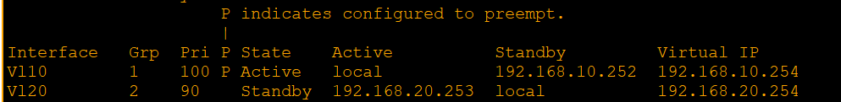

Spanning Tree & EtherChannel
show spanning-tree vlan 10 brief (FROM L3SW1)
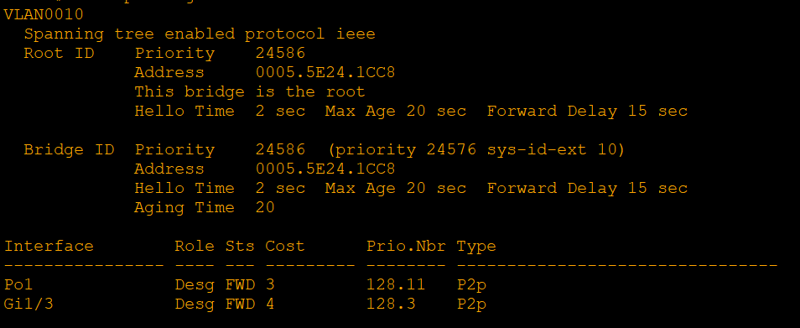
show etherchannel summary (FROM L3SW1)
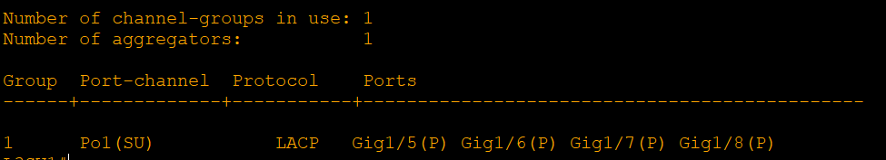

NAT
show ip nat translations (FROM R1)
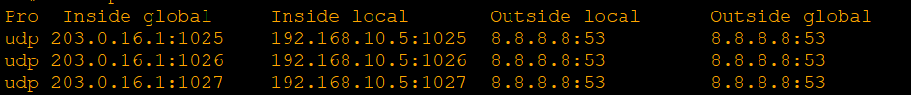
show ip nat statistics (FROM R1)
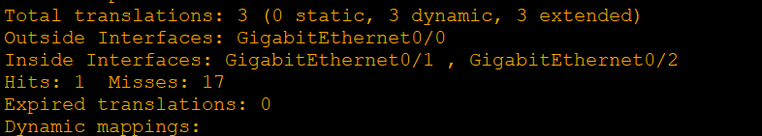

DHCP
show ip dhcp binding (FROM R1)
show ip dhcp pool (FROM R1)
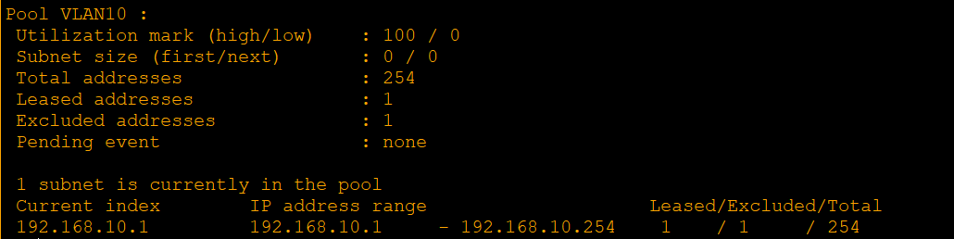

Security
show port-security interface fa0/1 (FROM SW1)
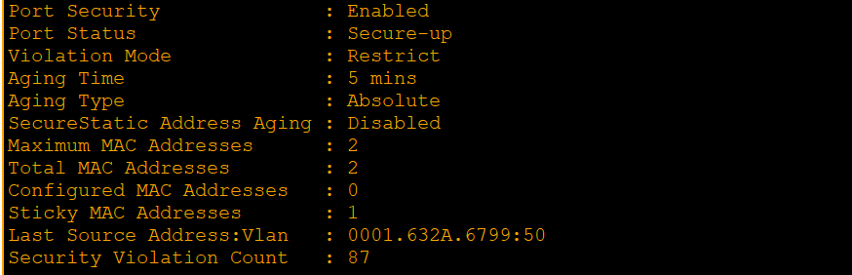
show ip dhcp snooping binding (FROM SW1)

show ip dhcp snooping (FROM SW1)
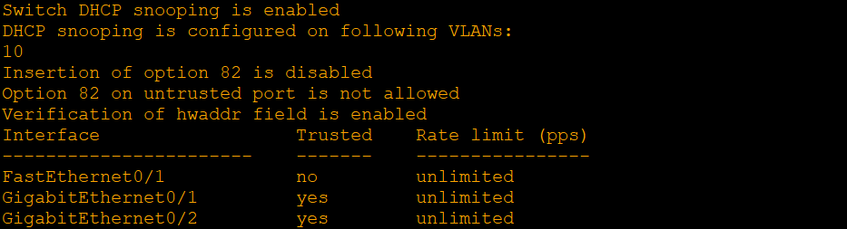
show ip arp inspection statistics vlan 10 (FROM SW1)
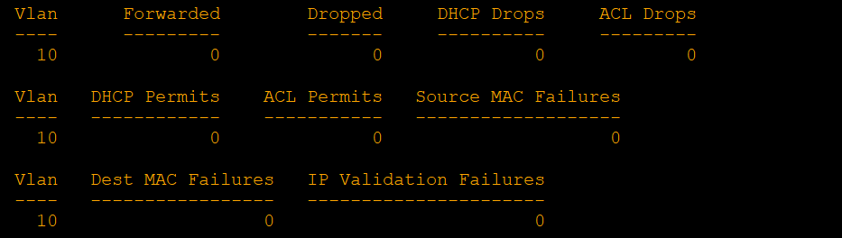
show ip access-lists (FROM L3SW1)

SSH
show ip ssh (FROM L3SW1)
ssh -l admin <device-ip> (FROM PC0)
